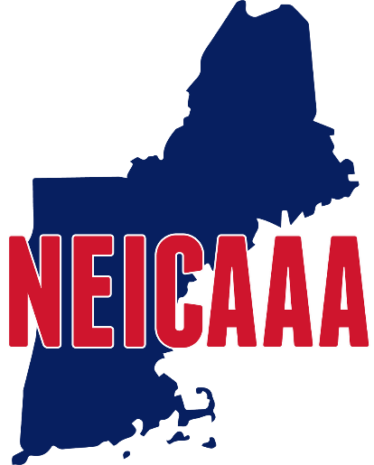

New England Intercollegiate Amateur Athletic Association

As per the Constitution, a convention of the Association shall be held during the month of September. Voting will be done by the Athletics Director or his/her representative. All votes will be recorded.

Representatives must present to the presiding officer of the convention written authorization from their Athletics Director stating his/her right to represent such college/university in all matters before the convention

Format for authorization to vote required by Article VI, Section 3

_______________________is authorized to represent

_______________________College/University at the September 13, 2022 NEICAAA convention

Signature of Athletics Director_____________________________
Please bring to the convention or text 508 944 7086, so as to be received prior to the convention.

Irwin Cohen
P.O. Box 220476
Dorchester, MA 02122

+++++++++++++++++++++++++++++++++++++++

